Name_________________________________________________________________

PERSUASIVE SPEECH (4-6 minutes): Choose a topic of local, national, or international concern, and express your opinion about it and attempt to persuade the class to your point of view. Use research materials from at least three sources (only one from the Internet). You must use a visual aid in the form of a graph or chart. The topic must be approved. A written outline must be submitted at the time of the speech. THIS SPEECH MUST BE COMPLETED ON SCHEDULE IN ORDER TO PASS THE COURSE

I will give my Persuasive Speech on (Topic): Saving $100 a month.
Attention Step- 100 words minimum

Hello, in my speech I will address the topic of saving at least $100 per month. We all have heard that saving is beneficial but today I will provide research-based details on why and how to save your money. Do you know that if you save $100 only per month and invest it at a 7% return rate the money will be worth $180,112.13 in thirty-five years (Mullainathan & Eldar 140-142)? The amount you will have saved will sum up to $42,000 which means that you will have earned a profit of averagely $138,000. Think about where you picture yourself to be in the next three and a half decades, then decide if having an extra $140,000 in your bank account will be advantageous or not.

Sources Cited:

Mullainathan, Sendhil, and Eldar Shafir. "Savings policy and decision-making in low-income households." Insufficient funds: Savings, assets, credit, and banking among low-income households 121 (2009): 140-42.

Need Step-100 words minimum

Most of us will graduate soon and start building and shaping our lives by beginning our careers and possibly getting families, which will mean that most, if not all, will become parents at a point. Hence, we will have to spend more than we do currently. In some cases, we may need to do things that require heavy cash investments like starting a business, clearing loans or buying a home. Unfortunately, there also may be cash related or medical emergencies that must be dealt with, all of which would require that one be financially prepared (Jorgensen & Savla 472). Therefore, the question is, would you prefer to be financially prepared when financial urgencies arise, or would you rather rely on the availability of bank loans that must be repaid with large amounts of interests on top?

Sources Cited:
Jorgensen, Bryce L., and Jyoti Savla. "Financial literacy of young adults: The importance of parental socialization." Family Relations 59.4 (2010): 465-478.

Satisfaction Step- 100 words minimum

I am sure by now most of you are thinking ‘I will need some money in future but how will I get it?’ I have the solution for you. We can manage to handle our future financial needs by saving only $100 per month. We are all students, some of whom may not have extra work and may be thinking that saving $100 is a big challenge. However, we can break it down to $25 a week and further into $5 per weekday. Does it not seem achievable?
Since we all have daily living costs, we need to learn how to use our financial system to create an extra $5 a day or $25 a week for our savings plan. The first step would be to open a bank account for the savings in a student-friendly bank that offers high interests on savings. Next, find ways to reduce your expenditure such as using library resources for secondary study material rather than buying them or decreasing your shopping budget by sharing cots with a friend (Cavender et al.). Once you have the money in your account, seek investment opportunities. Most banks offer free advice on where to invest your money and how to do it. You can majorly focus on buying stock or loaning the bank at an interest. However, you must use all resources available to research the guarantee of your investment, which is now easier considering that we live in a technological era (Dunnan)

Sources Cited:
Cavender, Nancy M., and Howard Kahane. Logic and contemporary rhetoric: The use of reason in everyday life. Cengage Learning, 2009.
Dunnan, Nancy. How to Invest $50-$5,000 10e: The Small Investor's Step-by-Step Plan for Low-Risk Investing in Today's Economy. Harper Collins, 2009.

Visualization Step- 100 words minimum

After you have saved and invested your money, you will get returns that are likely to be in cash lump sums. Your savings will also make you financially independent allowing you to make financial decisions without entirely depending on your pay cheque. This way, you can decide to get the new house, buy the new car or fund that dream holiday with your own money and spare your monthly income for other expenses. You can avoid extra cost such as paying interests on credit overdrafts or loan interests as you will have your own money to spend. The savings also provide a safety net in case of the loss of a job or an economic downturn causing a recession. When faced with medical emergencies, you will be able to handle the extra cost that the insurance is unable to cover thereby avoiding stressful events that may arise in such cases when the money supply is low (Brune et al.)

Sources Cited:
Brune, Lasse, et al. "Commitments to save: A field experiment in rural Malawi." (2011).

Action Step- 100 words minimum

Obviously, by now we agree that saving at least $100 a month can work a great deal in securing your future financially. Therefore, there are ways you and I can achieve such benefits. We should know that saving requires discipline and hard work. Be consistent in apportioning the $5 a day or $25 a week and bank it as soon as you can. Approach your investment research seriously and ensure that you cover all the important aspects. Also, group saving may be a strategic means of approaching the savings plan because that way we can encourage each other to achieve the goal. We can start by researching to find the best bank to open an account with then proceed to get a plan for achieving the set goal and finding ways to reduce expenditure (Walstad et al. 350). After we develop the saving habit, it will turn into a lifestyle which will facilitate consistent saving even after graduating and going our separate ways.

Sources Cited:

Walstad, William B., Ken Rebeck, and Richard A. MacDonald. "The effects of financial education on the financial knowledge of high school students." Journal of Consumer Affairs 44.2 (2010): 336-357.

Visual Aid Chart or Graph

The graph below depicts the essence of time and money while saving. Starting to save early in life with lower amounts makes you end up having more money compared to saving higher amounts when you get older (Kiersz).

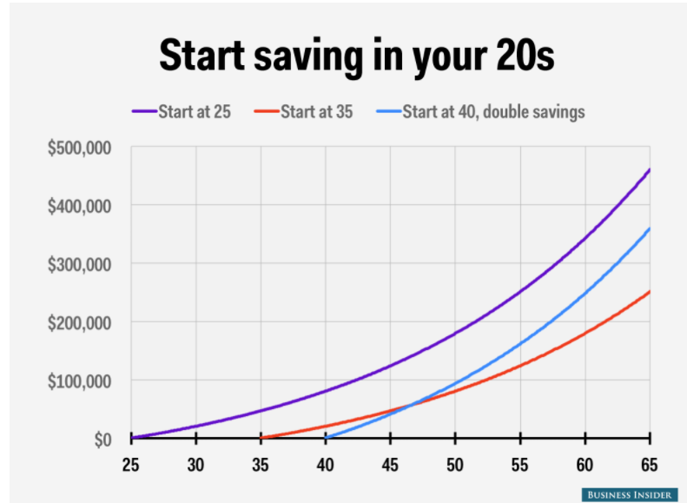

Citation:

Kiersz, Andy. "Actually, Young People SHOULD Invest in Their 401(K) Plans ...." Business Insider, 2017, http://uk.businessinsider.com/compound-interest-and-young-people-2015-4?IR=T.

